Week 7 - Seminar Questions
To get ready for the seminar, please attempt formative tests. The seminars are problem classes based on formative tests. Below you can find a sub-set of questions which will be discussed in detail during the seminar.

- ANOVA looks at:

  - the difference of means over a standard deviation.
  - the (weighted) variance between groups compared to the (weighted) variance within groups.
  - whether a coefficient is significantly different from 0.
  - two continuous variables against a straight line.

- A piece of research produces the following data:
Group A 31 15 14 21 35
Group B 26 25 43
Group C 29 37 19 16

What is the contribution to SSE (the Sum of Squares Errors - also known as "Within Groups") of Group C?

- A piece of research produces the following data:
Group A 2 3 9 10
Group B 2 4
Group C 4 5 6

What is SSG (the Sum of Squares Groups - also known as "Between Groups")?

- A piece of research produces the following data:
Group A 21 19 39 17 48
Group B 28 44 20
Group C 35 39 23 32

What is SST (the Sum of Squares Total)?

- A piece of research produces the following data:
Group A 36 17 27 13 20
Group B 19 28 43
Group C 22 33 34 24

What is the Test Statistic?

- Which of the following is a correct interpretation of the following SPSS output?

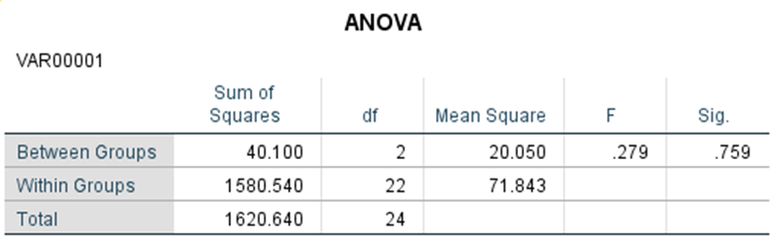

- There were 24 datapoints.
- Because 0.759 > 0.279, we reject the null hypothesis and conclude that at least one group is significantly different from the rest.
- There were 22 groups.
- We fail to reject the null hypothesis - no group seems to be significantly different.

